CHATTERON.IO

**What is ChatterOn?**

ChatterOn is a bot development platform which gives you the required tools to build Facebook Messenger chatbots without any coding.

**Account creation using,**

* Github
* Google+
* Facebook

**Pricing**

Free: The platform is free until 15,000 messages per month.

Cost: $0.0010/messages – Unlimited bot, unlimited messages.

**Advantages:**

**Bot module:**

* Create Module using Add module option,
* Can make the bot using Conditional flow
* Add button, Quick reply option, Text, Image , File
* Can add carousel.
* For the button we can add URL link as well as text content.

**Bot NLU(Natural Language understanding** **) Concepts**

* Intent
* Entity

**Integration**

* Facebook
* Website – Using < body> tag script

Embed Code:

<script>

function codeAddress() {

chatterOnInit({

chatterOnClientID: "Your client id",

themeColor : "set theme color here",

label : "your widget label"

});

/* botID with access token, display bot icon?, modal width, modal height, call to action image */

/* you may also invoke chatterOn_Open(); to manually open the modal */

}

</script>

<script src="http://dashboard.chatteron.io/web-sdk/scripts/web-sdk.js" onload="codeAddress();"></script>

* Facebook promotions.

**Dynamic API response**

* Rest API

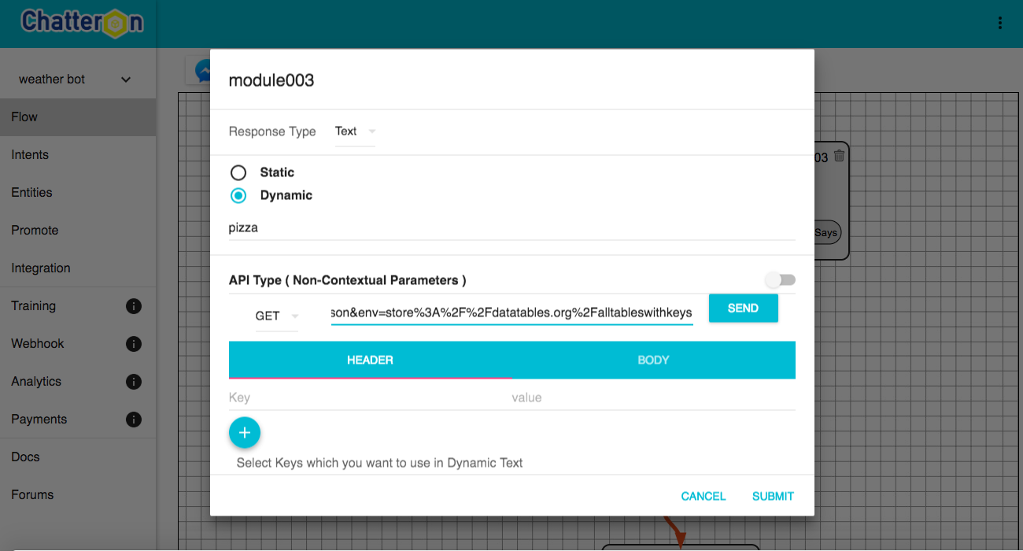

* Context API
* Non-Context API

**Features**

* We enable setting up of your business logic dialogue using powerful AI/ML models
* We provide support for rich content dynamic payloads like Carousels, Buttons, Quick Reply
* The platform supports seamless integration of your back-end APIs.

**Demo**

